Result analysis for the development of an online Furniture shopping website.

****

Lukas Meiliunas

Joshua McGrath

Jamie Nolan

1. Survey Overview:

We as a group conducted an online survey to over 15 people to find out where the aim for our website should be directed towards. The survey consisted of 10 questions which are relevant to different steps of making this website successful.

* How often do you buy Products online?
* What type of furniture do you typically buy online?
* How do you prefer to buy furniture?
* How much would you budget be?
* Do you use PayPal?
* Delivery / Collection?
* Do you prefer buying from Company / Person?
* What do you believe is most important?
* Are you familiar with a review and comment system?
* Have you ever had any bad experiences with online shopping?
  1. Analysis:

The first question of the survey is ‘ How often do you buy products online?’ this question was asked to find out if people are actually interested buying products online and if so how often.

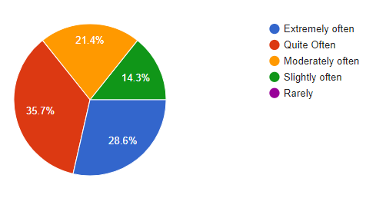

We noticed that from over 15 people 0% of them actually did not use online shopping. This was very surprising to us!

From these unexpected results we asked the participants ‘What type of furniture do you buy online?’ This was probably one of the most important questions in this survey as this was the factor which would later influence our website of what type of furniture to sell.

There was various answers ranging from Bedroom furniture, Decoration, Toilet furniture, Sofa Book casing and lighting. From these results we came up of an idea that the website index page will have various pictures which work as links to different pages leading on to Bedroom, Kitchen, Living room, Toilet, Sitting room.



The picture will act as a hyperlink to the relevant category.

We were thinking of implementing a ‘PayPal’ service in the transaction process as over 55% of the people who answered this survey used PayPal.

